NAME –CHANDAN – KUMAR

Course-Computer science

Roll .no – 16022 , Sec –A

Sub – Operating system

PRACTICAL LIST PROGRAM

Q-8 ) WRITE A C++ PROGRAM TO IMPLEMENTATION OF FCFS SCHEDULING ALGORITHM

+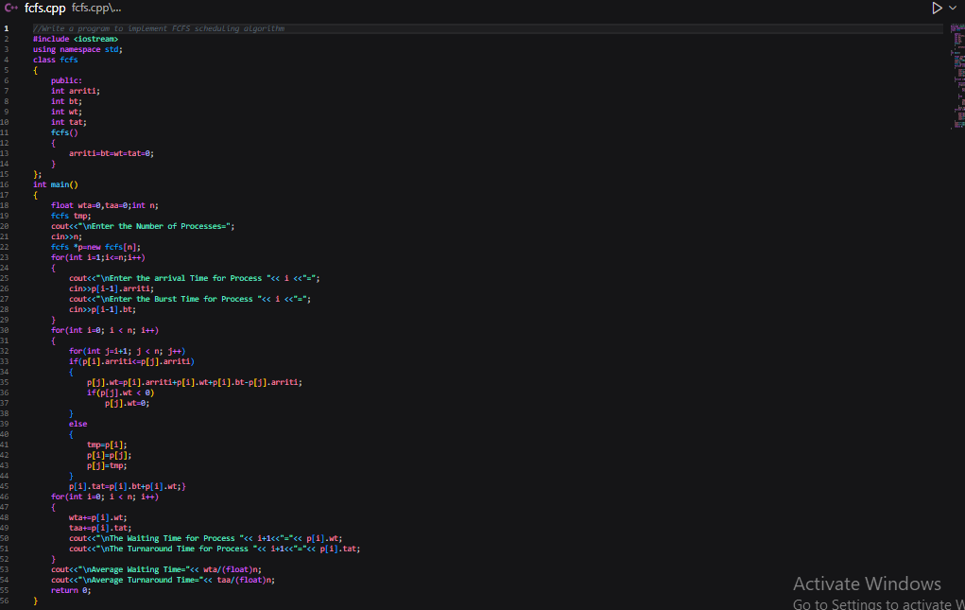

FCFS OUTPUT -----------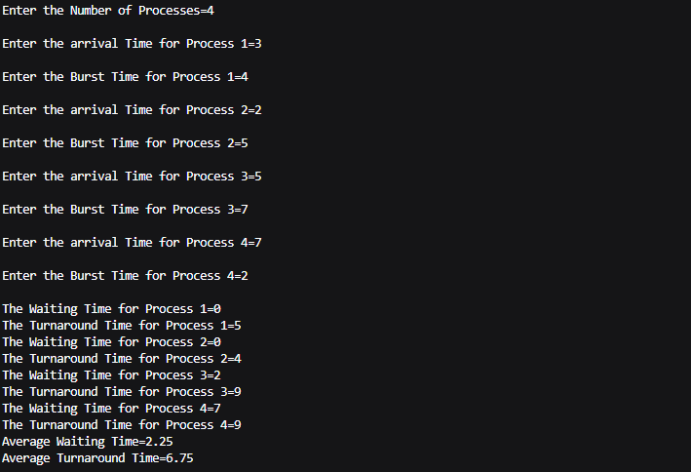

Q-4 ) LINUX C PROGRAM USING FORK() COMMAND TO EXECUTE PARENT AND CHILD

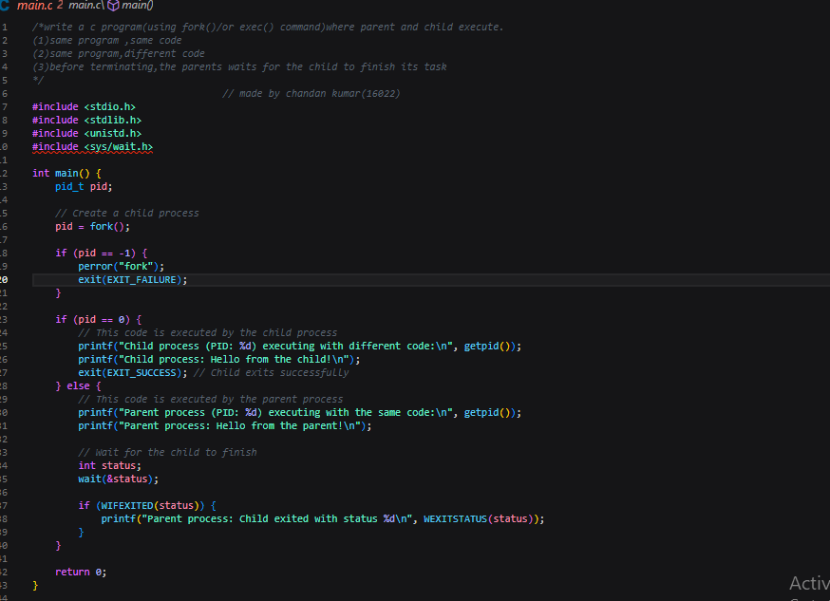

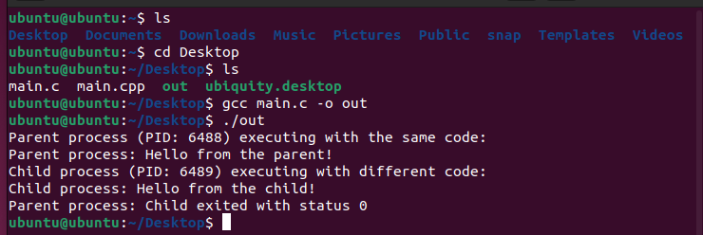

Q-10) Write a C++ program to implement non-preemptive priority based scheduling algorithm

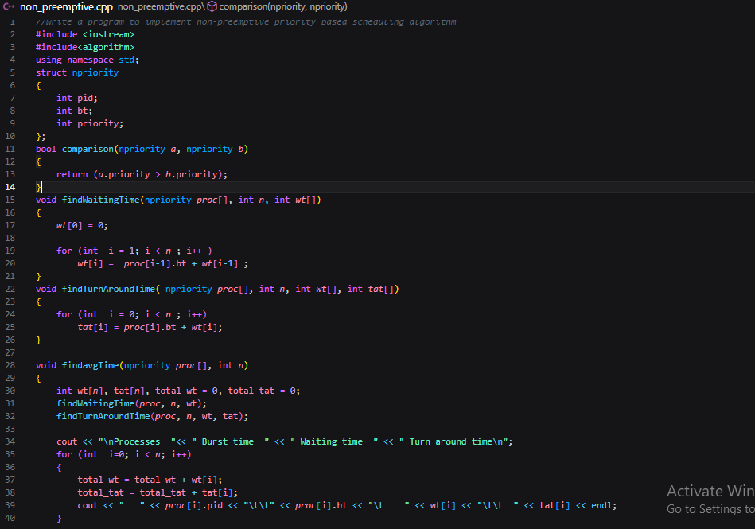

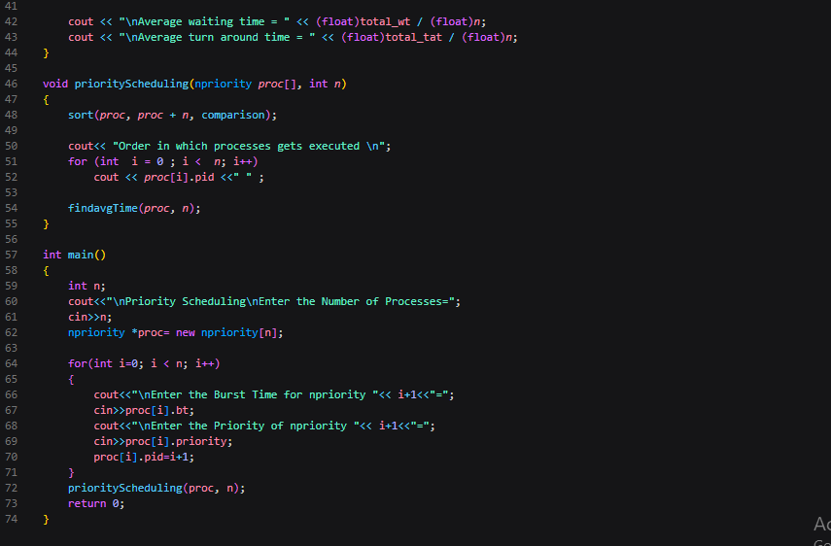

Priority based scheduling alg _output----

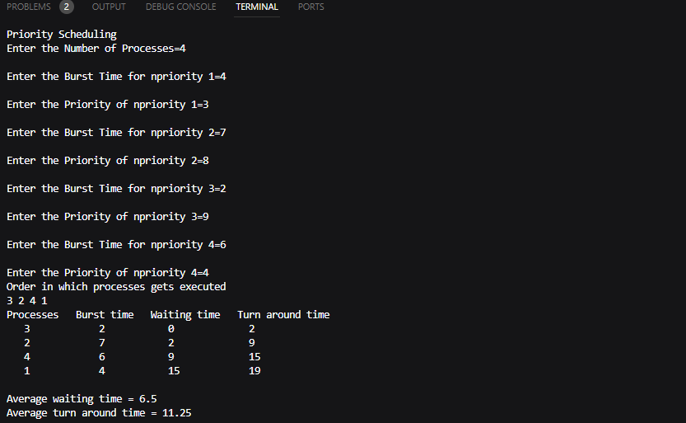

Q-9) implementation of SJF SCHEDULING ALGORITHM

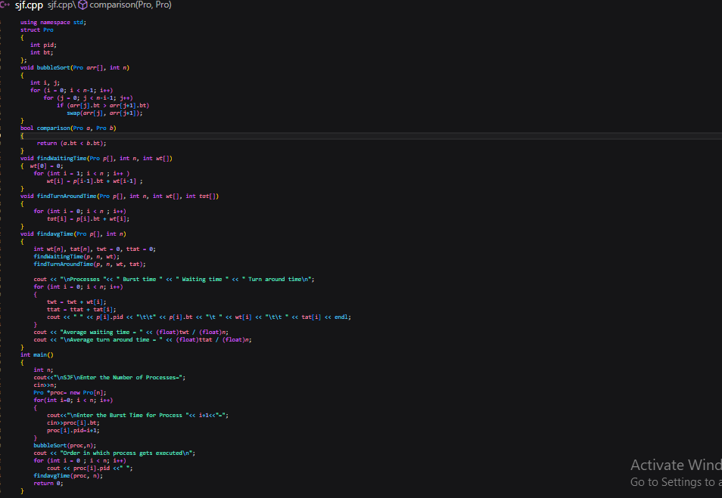

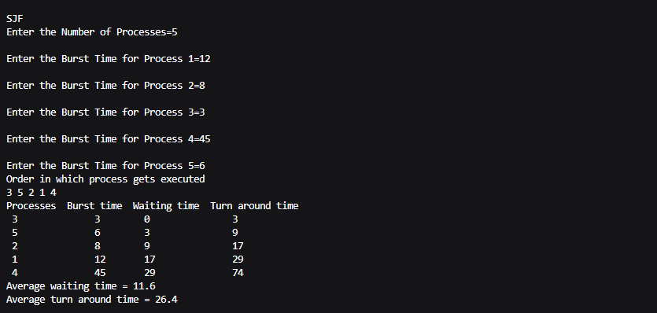

Q -11) write a c++ program to calculate sum of n numbers using pthreads on LINUX terminal

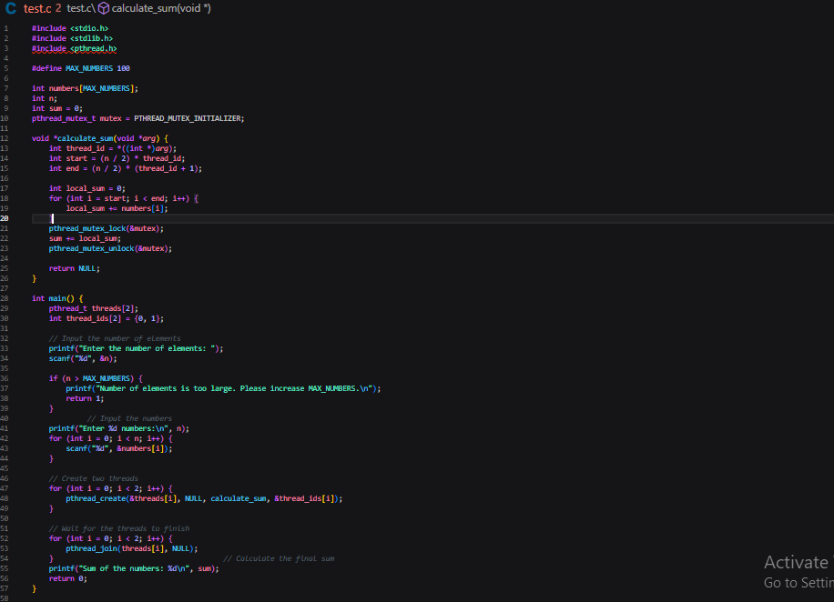

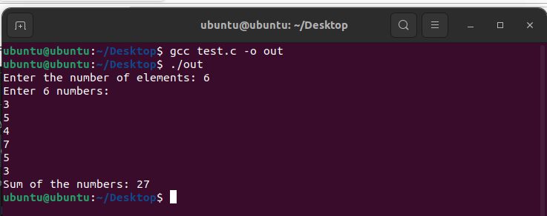

Q-12) –First fit ,Best fit ,Worst fit allocation strategies

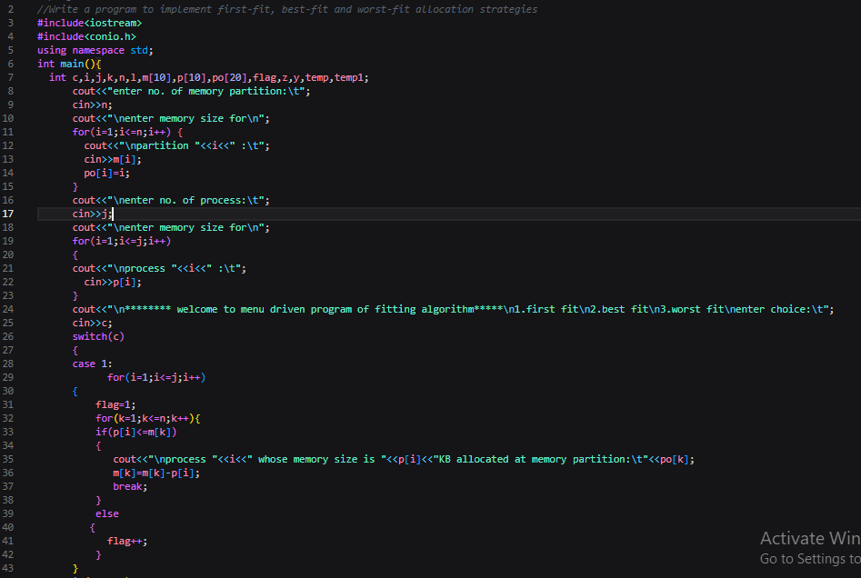

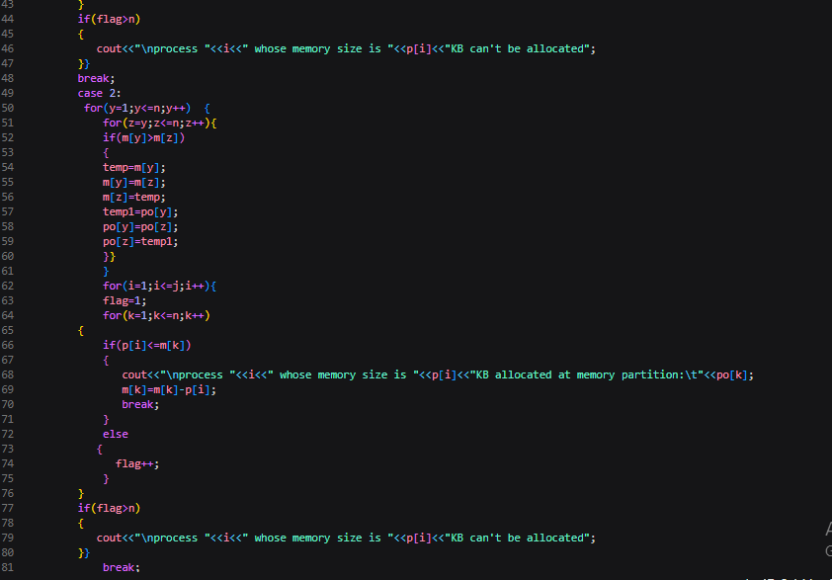

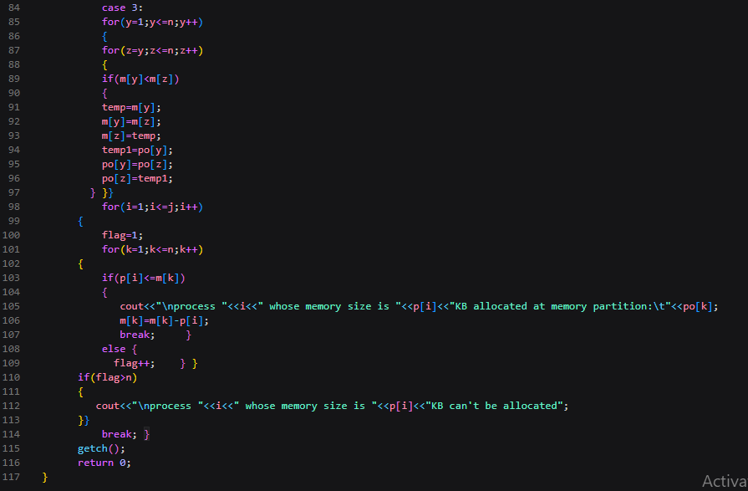

Output –

